

CS152

Human Computer Interaction

NeuroPal

(Mental Health Tracker)

Part 2: Designing Alternatives

A Project Proposal By:

Void

Dela Serna, Adrianne Faye

Javines, Kienth Justine

Dolorito, J-mar

May 24, 2024

1. Project Description

NeuroPal is a comprehensive mental health application designed by Team Void to provide users with a range of tools and resources to manage their mental well-being. The app addresses the increasing demands of modern life by offering features such as mood tracking, journaling, mindfulness exercises, and community support, all within a single, unified platform. NeuroPal is designed with accessibility and user-centric principles in mind, ensuring that individuals from diverse backgrounds can benefit from its offerings. The app aims to create a secure, supportive space where users can express their feelings, set personal goals, and access professional help when needed. By integrating multiple mental health support features, NeuroPal seeks to enhance the overall well-being of its users.

1. Requirements Summary

**User Interface and Navigation:** The system must have an intuitive interface that is easy to navigate, ensuring users can effortlessly access various features such as mood tracking, journaling, and mindfulness exercises.

**Mood Tracking:** Daily mood logging with options to describe feelings and add context. Visual mood charts track patterns and trends over time.

**Journaling**: A secure space where users can write about their experiences and ideas, with customized exercises to guide their reflections.

**Mindfulness Exercises:** Guided meditations and breathing exercises designed to reduce stress and promote mental clarity.

**Mood and Activity Log:** Logging activities and correlating them with mood entries to help users identify triggers and patterns.

**Void (For Ranting and Anger Management):** A dedicated space for users to vent their frustrations and manage anger healthily.

**Time Capsule:** A feature allowing users to write messages to their future selves with delivery dates, promoting self-reflection and long-term goal setting.

**Goal Setting and Progress Tracking:** Tools for setting and tracking academic and personal goals, with visual progress indicators.

**Community Support Group:** Forums and groups where users can share experiences, offer support, and receive encouragement from peers.

**Crisis Support and Resources:** Easy access to emergency contacts and crisis support services, providing immediate help when needed.

**Therapist Directory and Teletherapy:** A directory of licensed therapists with options for booking teletherapy sessions for professional mental health support.

**Educational Resources:** A collection of articles, videos, and resources on mental health topics relevant to users' needs, enhancing their knowledge and coping strategies.

**Accessibility and Compatibility:** The app should be accessible across iOS and Android devices, ensuring broad usability.

1. Design Space

In designing NeuroPal, it is crucial to maintain a consistent and user-friendly design that is both visually appealing and easy to navigate. The design should feature a clean, modern aesthetic with clear writing and symbols that users can understand. Consistency in colors, fonts, and symbols across the interface will help users feel comfortable and easily locate the features they need. The app's accessibility features must ensure that it can be used by individuals with varying levels of technical proficiency and from diverse backgrounds.

1. Design Summary

We opted to pursue a design that combines simplicity with visually engaging elements. This design strikes a balance between minimalist aesthetics and visual appeal, making it attractive and engaging for users. Its simplicity ensures ease of navigation and clarity in presenting information, contributing to a seamless user experience. Additionally, eye-catching elements draw users' attention to key features and functionalities, enhancing ease of usability and engagement. The focus on user-centric design ensures that NeuroPal remains accessible and valuable to a broad audience.

1. **The Designs**

**Storyboard**

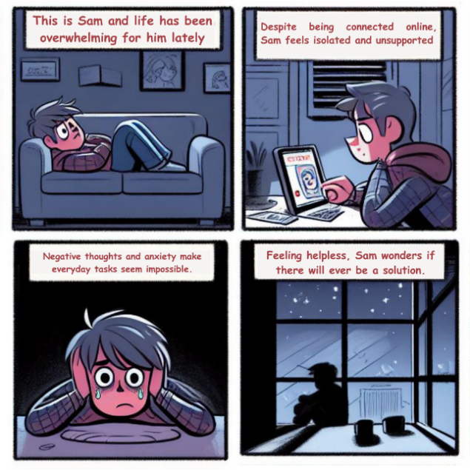

**Sketches**

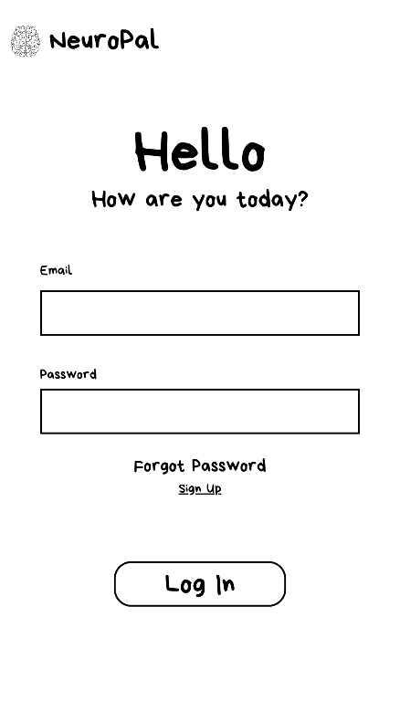 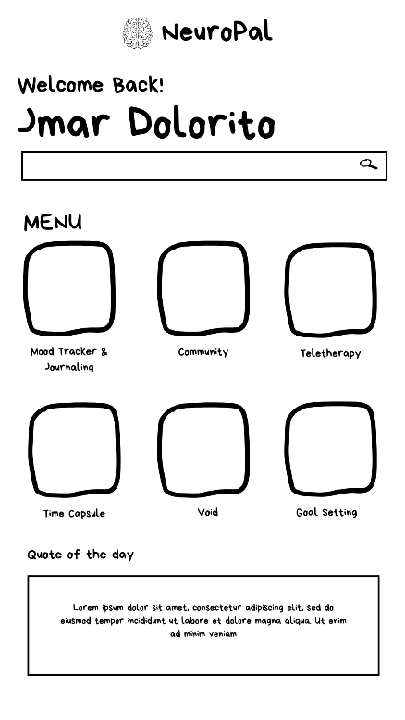 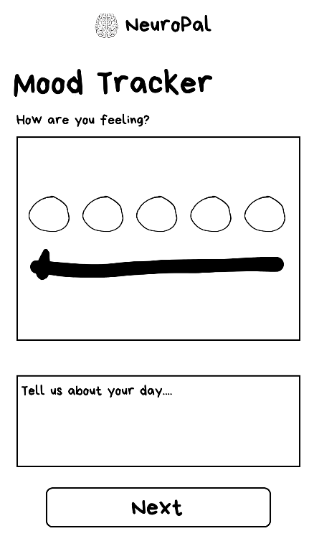

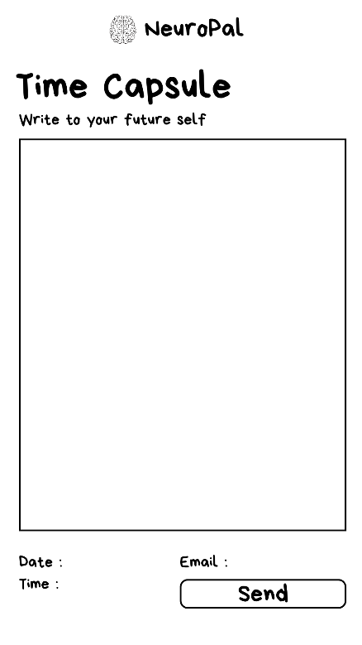 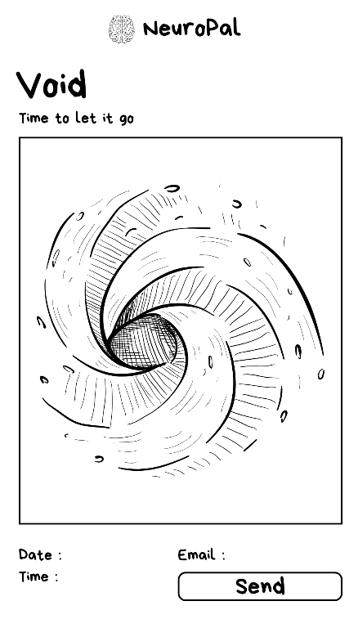 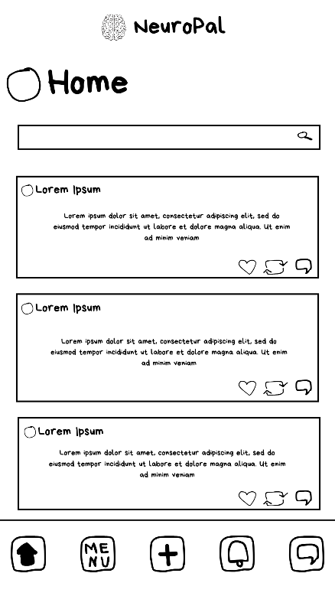

**DESIGN 1 color palette:**

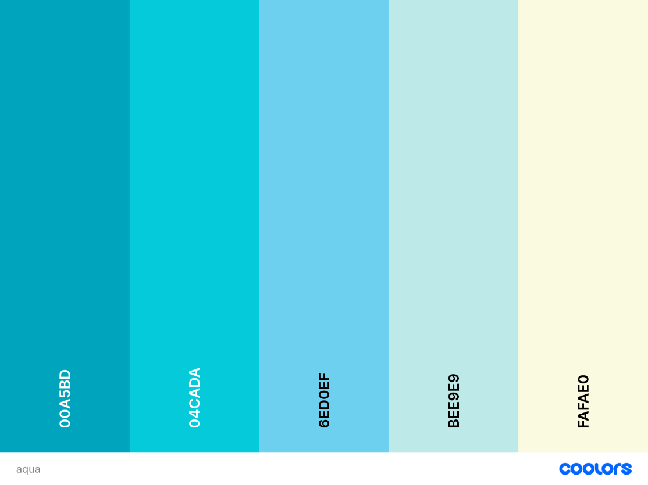

The color palette for NeuroPal, featuring shades of blue and a light yellow, is thoughtfully chosen to enhance user experience and convey emotional states. The vibrant aqua (#00A5BD) serves as the primary color for key elements like buttons and headers, evoking calmness and clarity, while the lighter aqua (#04CADA) is used for secondary elements, promoting tranquility. The soft blue (#6ED0EF) is ideal for backgrounds of input fields, creating a sense of openness, and the pastel blue (#BEE9E9) is used for larger sections to reduce visual stress. The light yellow (#FAFAE0) is strategically applied to accents, success messages, and highlights, associated with happiness and positivity. This combination of calming blues and cheerful yellow balances the emotional tones within the app, making it inviting and supportive, thus encouraging users to engage and take positive steps in their mental health journey.

**Design 1:**

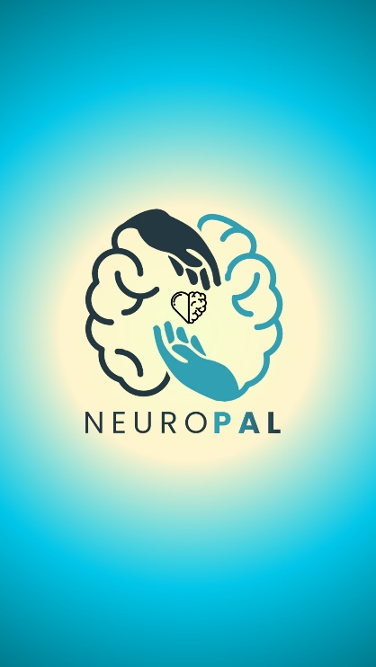 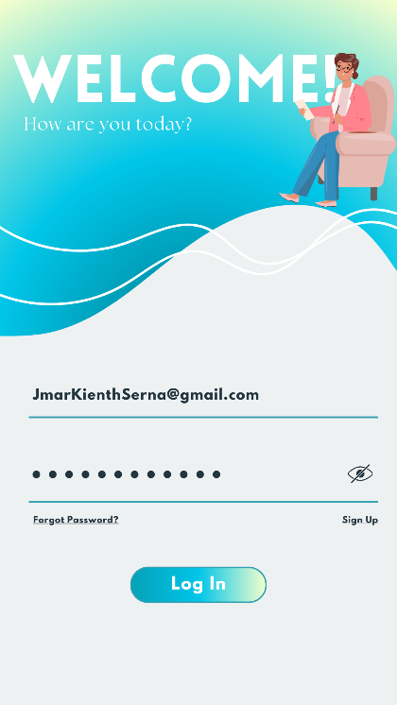

**Loading and Log In Page**

This page allows users to input their account details to securely log in and access their personalized dashboard. New users can easily sign up by providing their information, ensuring a seamless and efficient onboarding process. Sign in or create an account to unlock all the features and benefits our platform has to offer.

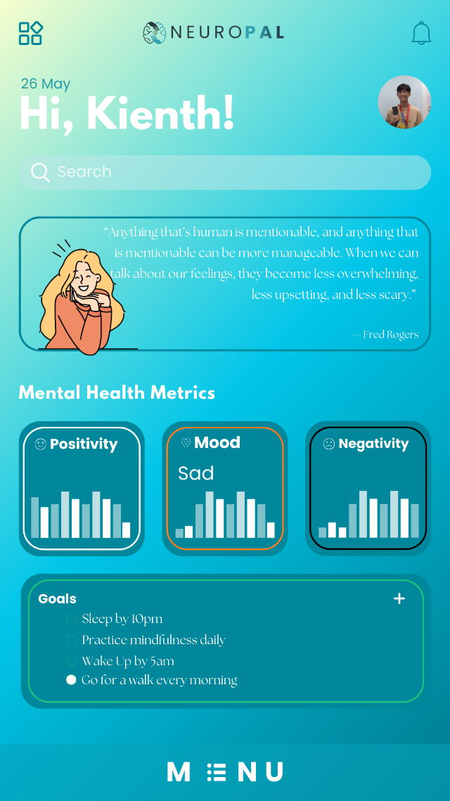

**Main Page**

The main page provides a comprehensive view of your mental health metrics, including graphs that track positivity, mood, and negativity based on this month's records. You can set and monitor your personal goals, receive daily mental health quotes for inspiration, and utilize the search bar to quickly find specific features within the app. Stay informed and motivated with easy access to all your mental wellness tools in one place.

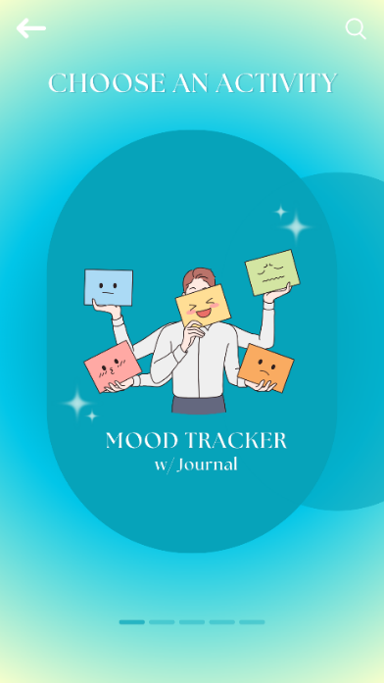 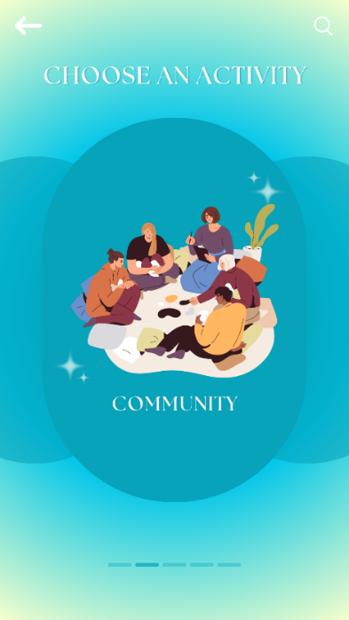 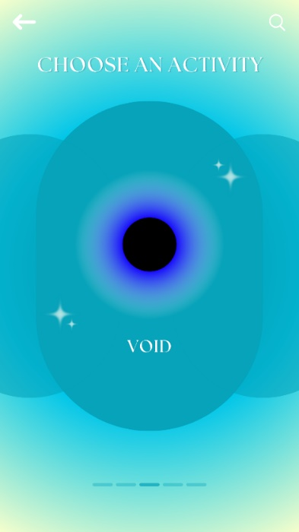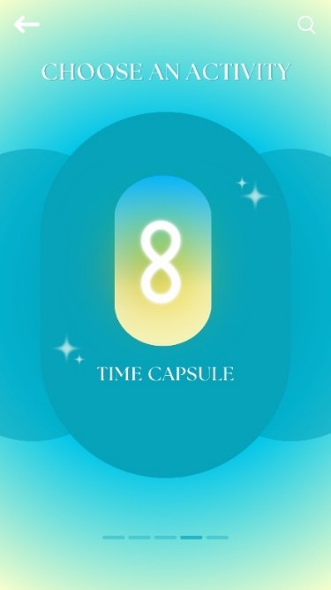 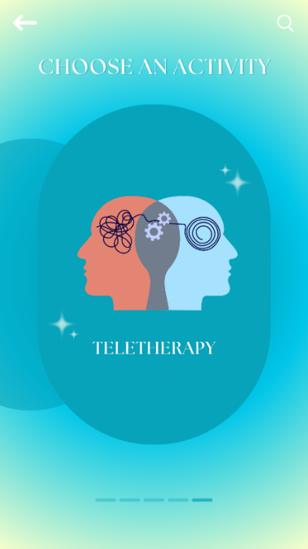

**Menu Page**

This menu page features a vibrant and intuitive design that invites users to choose an activity tailored to their mental health needs. The background gradient transitions smoothly from a calming light yellow to a serene blue, creating a soothing visual experience. At the center, an engaging illustration depicts a character holding various mood icons, emphasizing the mood tracker with a journal. The clean typography and easily recognizable icons ensure that users can navigate the menu effortlessly. Additional activities like community engagement, the void for personal reflections, time capsule, and teletherapy can be accessed via the search bar or by swiping through the options, making it simple and enjoyable to find and select the desired feature.

**Design 2**

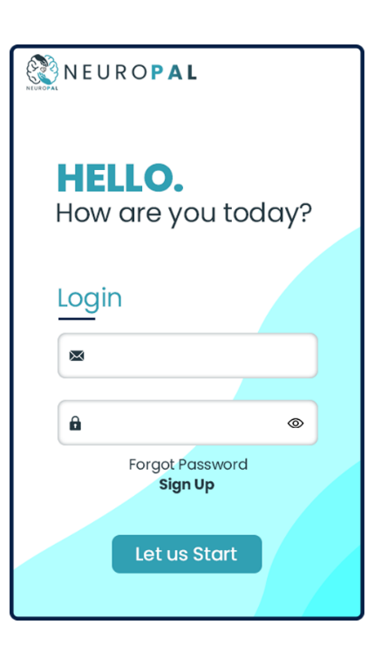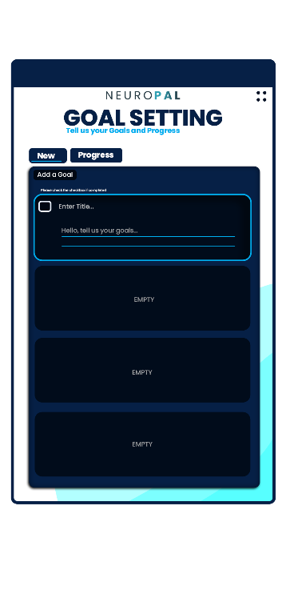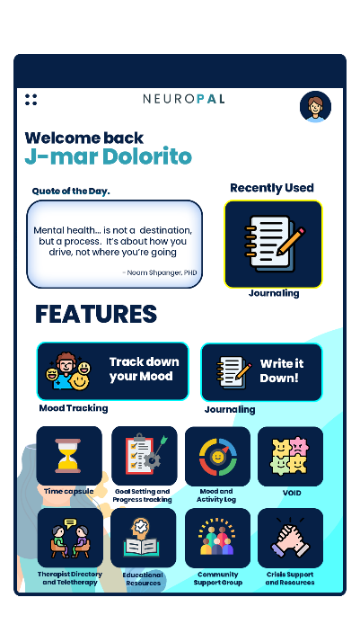

**Design 3**

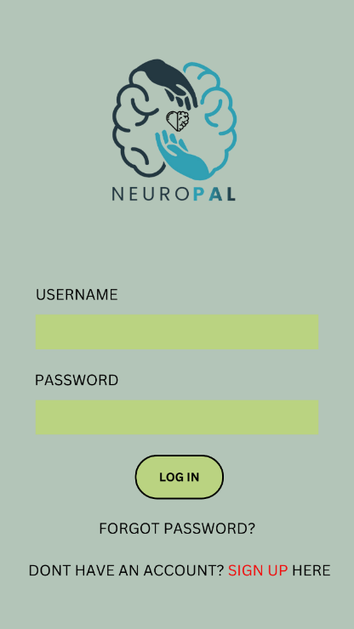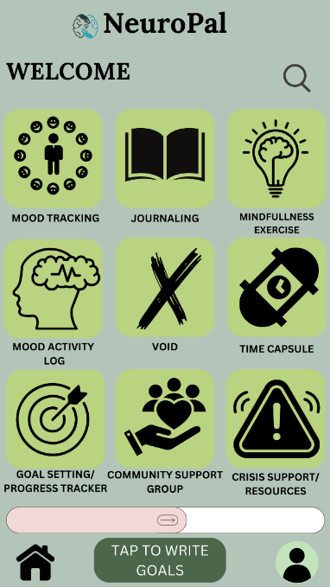

This is Design is simple and calm, like a quiet room with few things. It's about using just what's needed, nothing more. The colors are mixed with blue and green, making the space feel open and peaceful. Features are simple and useful, without fancy shapes or decorations. Everything has a purpose, and there's no clutter. Additional functions such as home page, user and even search bar are easy to spot for the user. This design is recognizable with its easy function.